

Great Staughton Primary Academy

School Uniform Policy



Signed: S.Whiting Date: December 2023
Headteacher

Signed: S.Thompson Date: December 2023
Chair of Governors
Contents:

- Introduction & statement of intent

- Legislation & Guidance

- Limiting the cost of school uniform

- Expectations for school uniform

- Arrangements for our school uniform

- Expectations for our school community

- Monitoring arrangements

- Links to other policies

- Appendix 1

- Introduction & Statement of Intent
Our policy on school uniform is based on the belief that school uniform:
  - Promotes the ethos of our school and a sense of pride
  - Provides a sense of belonging and school community
  - Creates a shared identity and common sense of purpose
  - Supports our commitment to inclusion
  - Promotes positive behaviour for learning with the aim of enabling all children to achieve their potential

This policy aims to:
- Set out our approach to requiring a uniform that is of reasonable cost and offers the best value for money for Parents and Carers.
- Explain how we will avoid discrimination in line with our legal duties under the Equality Act 2010.
- Clarify our expectations for school uniform.

- Legislation & Guidance
Our school’s legal duties under the Equalities Act 2010:
The Equality Act 2010 prohibits discrimination against an individual based on the protected characteristics, which include sex, race, religion or belief, and gender reassignment.

To avoid discrimination, our school will:
  - Avoid listing uniform items based on sex, to give all children the opportunity to wear the uniform they feel most comfortable in or that most reflects their self-identified gender
  - Make sure that our uniform costs the same for all children
  - Allow all children to have long hair (the expectation is that this to be tied back) and to style their hair in the way that is appropriate for school yet makes them feel most comfortable
  - Allow children to request changes to swimwear for religious reasons
  - Allow children to wear headscarves and other religious or cultural symbols
  - Allow for adaptations to our policy on the grounds of equality by asking children or their parents to get in touch with the Headteacher who can answer questions about the policy and respond to any requests

- Limiting the Cost of School Uniform

We know that our diverse community appreciate our traditional approach to school uniform and parents and visitors have always said how their children feel proud to wear our uniform and how it raises their self-esteem.
Our school does have a duty to make sure that the uniform we require is affordable, in line with statutory guidance from the Department for Education on the cost of school uniform.
We understand that items with distinctive characteristics (such as branded items, or items that require a school logo or a unique fabric/colour/design) cannot be purchased from a wide range of retailers and that requiring many such items limits parents’ ability to ‘shop around’ for a low price.

We will make sure our uniform:
  - Is available at a reasonable cost
  - Provides the best value for money for Parents and Carers

We will do this by:
  - Carefully considering whether any items with distinctive characteristics are necessary
  - Allowing children to wear non-branded clothing as long as they are in the correct uniform colours. We do suggest that at least one branded polo shirt and one branded sweatshirt or cardigan is obtained.
      - Limiting any items with distinctive characteristics as ‘optional’ so parents can find cheaper alternatives if required
  - Considering cheaper alternatives to school-branded items, such as bags and coats
  - Avoiding specific requirements for items children could wear on non-school days, such as coats, bags, and shoes
      - Keeping the number of optional branded items to a minimum, so that the school’s uniform can act as a social leveler
  - Making sure that arrangements are in place for parents to acquire second-hand uniform items
  - Avoiding frequent changes to uniform specifications and minimising the financial impact on Parents and Carers of any changes
  - Consulting with Parents, Carers and Children on any proposed significant changes to the uniform policy and carefully considering any complaints about the policy

- Expectations for School Uniform

It is our school policy that all children wear school uniform when attending school, or on occasions when children are representing the school, including school visits. We endeavour to achieve a high standard in all aspects of school and expect this to be reflected in both the appearance and behaviour of our children. Uniform plays an important part in establishing the ethos of the school in several ways. We believe that school uniform provides children with a sense of community and identity with their school. We want our children to be smart in their uniform and wear it with pride.

Parents and Carers are asked to co-operate fully by providing the uniform and ensuring children wear it correctly to and from school, and at other times as required.

4.1 Great Staughton Primary Academy Uniform List:

Please ensure that all articles of clothing and other items brought into school are clearly
marked with your child’s name.

Please refer to the table on the following pages for the school’s uniform list, including details on required and optional uniform requirements, and where to buy specific items.

Uniform Item | Photos | Required or  Optional | Where to purchase –  available at
Sweatshirt or cardigan  Burgundy with an embroidered badge. | 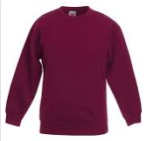  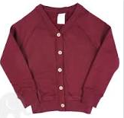 | Required -  One branded item is suggested | School Trends website: https://www.schooltrends.co.uk/uniform/GreatStaughtonPrimaryAcademyPE195BP  Any high street retailer or supermarket of parents’ choice
White polo shirt  Please note: to be worn tucked in at all times | 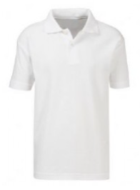 | Required  One branded item is suggested | School Trends website: https://www.schooltrends.co.uk/uniform/GreatStaughtonPrimaryAcademyPE195BP  Any high street retailer or supermarket of parents’ choice
Year 6 only  Sweatshirt or cardigan  Navy blue with an embroidered badge. | 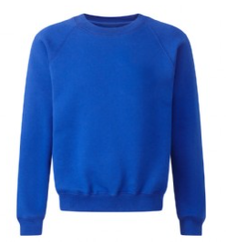  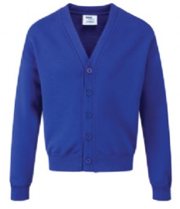 | Required -  One branded item is suggested | School Trends website: https://www.schooltrends.co.uk/uniform/GreatStaughtonPrimaryAcademyPE195BP  Any high street retailer or supermarket of parents’ choice
Year 6 only  Blue polo shirt  Please note: to be worn tucked in at all times | 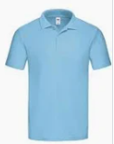 | Required  One branded item is suggested | School Trends website: https://www.schooltrends.co.uk/uniform/GreatStaughtonPrimaryAcademyPE195BP  Any high street retailer or supermarket of parents’ choice
Grey trousers or shorts | 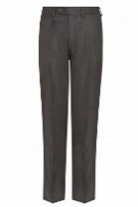 | Required | Any high street retailer or supermarket of parents’ choice
Grey Pinafore or skirt | 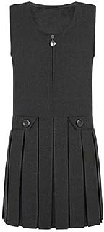 | Required | Any high street retailer or supermarket of parents’ choice
Year 6 only  Blue and white gingham dress or playsuit | 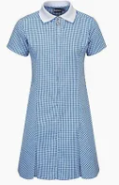 | Optional | School Trends website: https://www.schooltrends.co.uk/uniform/GreatStaughtonPrimaryAcademyPE195BP  Any high street retailer or supermarket of parents’ choice
Burgundy and white gingham dress or playsuit | 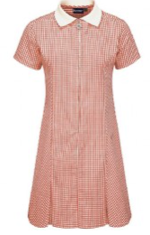 | Optional | School Trends website: https://www.schooltrends.co.uk/uniform/GreatStaughtonPrimaryAcademyPE195BP  Any high street retailer or supermarket of parents’ choice
Grey or white socks or grey or navy tights |  |  | Any high street retailer or supermarket of parents’ choice
Black shoes  See appendix 1 for examples of what is acceptable | 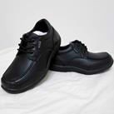  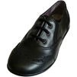    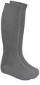 | Required | Any high street retailer or supermarket of parents’ choice
Sun hat or cap | 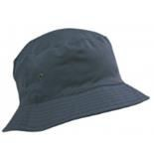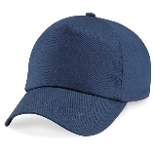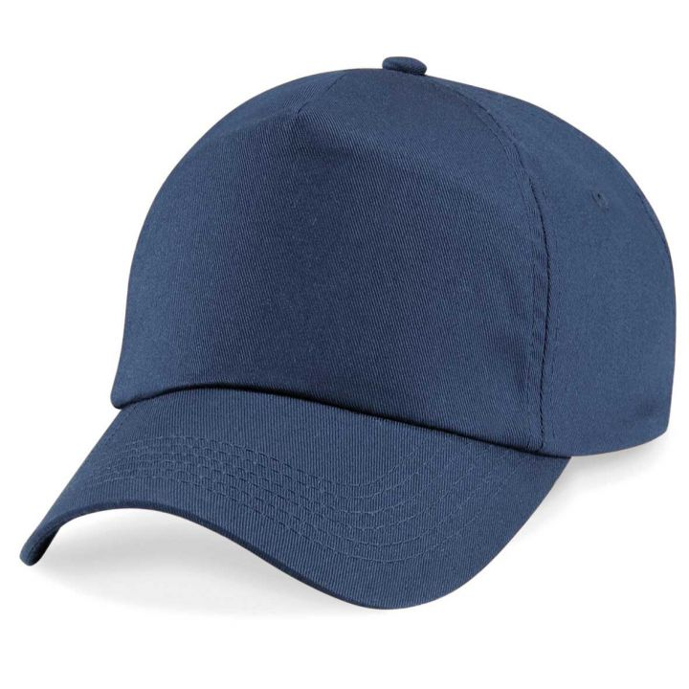 | Required | School Trends website: https://www.schooltrends.co.uk/uniform/GreatStaughtonPrimaryAcademyPE195BP  Any high street retailer or supermarket of parents’ choice
Book bag  School bag | 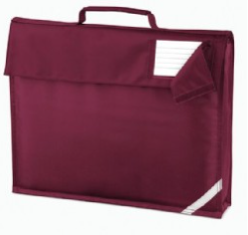 | Optional (book bag)  Required (bag) | School Trends website: https://www.schooltrends.co.uk/uniform/GreatStaughtonPrimaryAcademyPE195BP  Any high street retailer or supermarket of parents’ choice
Winter coat  The school branded coat is optional | 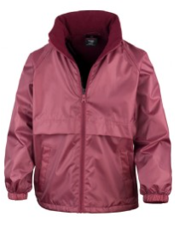 | Required | School Trends website: https://www.schooltrends.co.uk/uniform/GreatStaughtonPrimaryAcademyPE195BP  Any high street retailer or supermarket of parents’ choice

PE Kit Items | Photos | Required or Optional | Where to purchase
Plain white PE T-Shirt  Branded t-shirt is available but not compulsory | 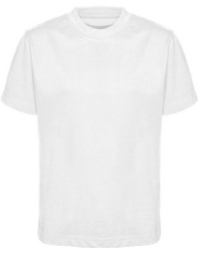 | Required | School Trends website: https://www.schooltrends.co.uk/uniform/GreatStaughtonPrimaryAcademyPE195BP  Any high street retailer or supermarket of parents’ choice
Navy or black PE shorts – Football style only | 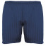 | Required | School Trends website: https://www.schooltrends.co.uk/uniform/GreatStaughtonPrimaryAcademyPE195BP  Any high street retailer or supermarket of parents’ choice
Navy blue or black jogging bottoms or track suit pants | 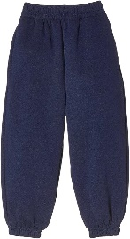 | Required | School Trends website: https://www.schooltrends.co.uk/uniform/GreatStaughtonPrimaryAcademyPE195BP  Any high street retailer or supermarket of parents’ choice
Trainers | 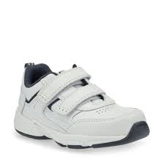 | Required | Any high street retailer or supermarket of parents’ choice
Plimsoles | 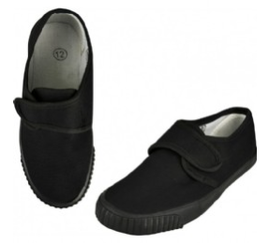 | Optional | School Trends website: https://www.schooltrends.co.uk/uniform/GreatStaughtonPrimaryAcademyPE195BP  Any high street retailer or supermarket of parents’ choice

4.2 Personal Appearance
Pupils are not allowed to wear hats, headscarves, or any other head covering inside the school building unless it is due to religious or cultural reasons. Any head covering for religious or cultural values or hair accessories that are worn such as slides, ribbons, bobbles etc. should be discreet.

Headwear and Religious Clothing
    - Religious headwear may be worn (for religious purposes only) and should be of a colour in line with the rest of their uniform.
    - Bandanas may not be worn as part of everyday uniform.
    - Sunglasses are not permitted at school unless they are prescription sunglasses. A sun hat or plain cap is more suitable for hot days.

Hair
    - Pupils’ hair should be neatly groomed at all times for smartness and health and safety. Long hair on all children should be tied back.
    - Extreme styles and hair colouring will not be permitted (as defined by the school).
    - Shaved lines in hair or eyebrows are not permitted.

Make-Up
    - Nail varnish and make-up is not permitted. Children wearing nail varnish to school will be asked to remove it.
    - Nails should not be a length that may cause injury to others (as defined by the school).

Jewellery/tattoos/piercings:
    - Pupils may not wear any jewellery except for one small watch only (no sound effects or games). Pupils are allowed to wear one pair of stud earrings, and they must be worn in the lower ear lobe. All studs must be removed for PE. Please note that the school does not take any responsibility for any watches or jewellery that are lost.
    - Body piercing is prohibited, with the exception of single, standard ear piercing. No other forms of body piercing will be allowed for any pupil.
    - Temporary tattoos are not permitted.

Coats and Bags:
    - Coats, when they need to be worn, should be appropriate for the school day and the weather. It is recommended that detachable luminous strips and/or arm bands are used by cyclists in the winter months.
    - Jackets or coats that the school deems as ‘hoodies’ are not permitted. Logos are not allowed.
    - All children are expected to use a school bag that fits an A4 folder inside, is robust and sensible.

- Arrangements for School Uniform

  - Where to Purchase School Uniform

Uniform items with specific school logo (or distinctive to school) can be purchased from our suppliers using the links below, who offer the full range of uniform, PE kit and accessories.

https://www.schooltrends.co.uk/uniform/GreatStaughtonPrimaryAcademyPE195BP
Uniform items that are generic can be purchased from a range of retailers or supermarkets, offering Parents and Carers a wider choice.
Where the children do not have the correct uniform, there is a stock of uniform in school that they will be able to borrow for the day.

5.2 Where to obtain school uniform: second-hand uniform arrangements

Great Staughton Primary Academy offer second-hand school uniform. For information regarding this, contact the school office.

EXPECTATIONS FOR OUR SCHOOL COMMUNITY

6.1 Children
Children are expected to wear the correct uniform at all times (other than specified non-school uniform days) while:
6.1.1 On the school premises
    - Travelling to and from school
    - At out-of-school events or on trips that are organised by the school, or where they are representing the school (if required)

6.2 Parents and Carers

Parents and carers are expected to make sure their child has the correct uniform and PE kit, and that every item is:
    - Clean
    - Clearly labelled with the child’s name
    - In good condition
The school welcomes children (or students) from all backgrounds and faith communities. If there are genuine reasons (for example religious considerations, medical needs or consideration of special needs), why parents want their child to wear clothes that differ from the school uniform, the school will consider adaptations. Parents are expected to contact the Headteacher if they want to request an amendment to the uniform policy in relation to:
    - Their child’s protected characteristics
    - The cost of the uniform
Parents are expected to lodge any complaints or objections relating to the school uniform in a timely and reasonable manner. Disputes about the cost of the school uniform will be:
    - Resolved locally
    - Dealt with in accordance with our school’s complaints policy

The school will work closely with parents to arrive at a mutually acceptable outcome.

MONITORING ARRANGEMENTS

School staff will closely monitor children to ensure compliance with the school’s uniform policy. Any non-compliance with the school uniform policy on a consistent basis will result in a letter being sent home and a formal request to adhere to the expectations outlined within this policy. Ongoing breaches of the school’s uniform policy will be dealt with in accordance with the school’s Behaviour Policy.

In cases where it is suspected that financial hardship has resulted in a pupil not complying with this uniform policy, staff will take a mindful and considerate approach to resolving the situation.

LINKS TO OTHER POLICIES

This policy is linked to our:

- Behaviour Policy
- Equality & Inclusion Policy
- Equality & Diversity Plan
- Anti-bullying Policy
Complaints Policy

Appendix 1
Acceptable | Unacceptable
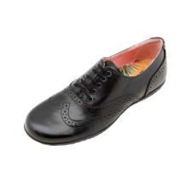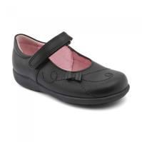  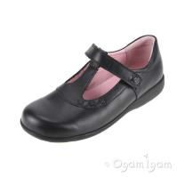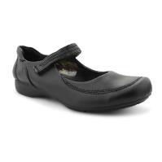  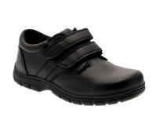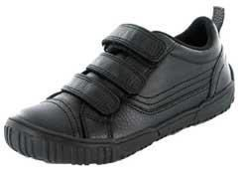  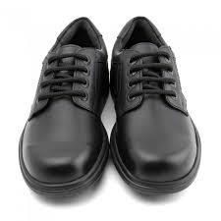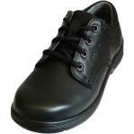 | 

