Thursday 7th January 2021
LO: To describe the human and physical features of where we live.
P | I can | CT
 | Must: locate where we live on a map.
 | Should: describe the human and physical features.
 | Could: describe the climate.

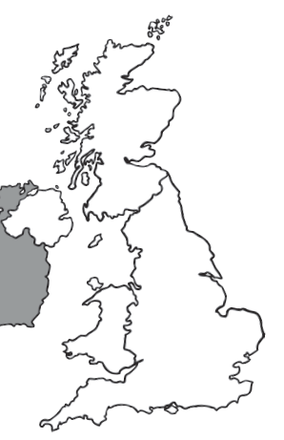
The UK is made up of human and physical features like…
Physical features are made by ___________.
There are
- _____________
- _____________
- _____________
- _____________
- _____________
- _____________
Human features are made by ___________.
There are
- _____________
- _____________
- _____________
- _____________
- _____________
- _____________

Can you draw a picture of one of the features in your list and write a sentence to explain what it is?

