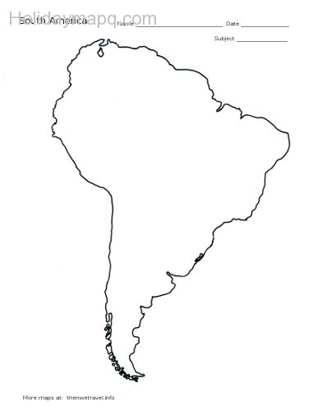
Human Features of South America
Physical Features of South America

