Wc 11th January 2020
Exciting Writing Task: Continue the story about the magic dog biscuits. What do the biscuits do to the dogs? What happens at the beginning/ middle and end of your story?
Capital letters &  Full Stops  A • |   Connectives | WOW  words | Careful  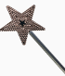  spelling | 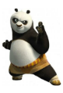  Kung fu punctuation | My writing makes sense.
Brian had often bought things from the market that had turned out to be the most outrageous, disappointing fakes.
He had presumed that the magic biscuits would have been exactly the same. How wrong he had been...






