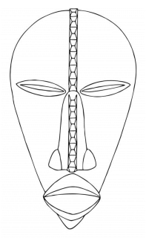
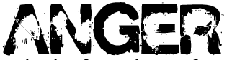
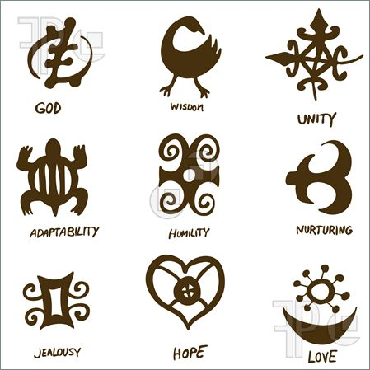
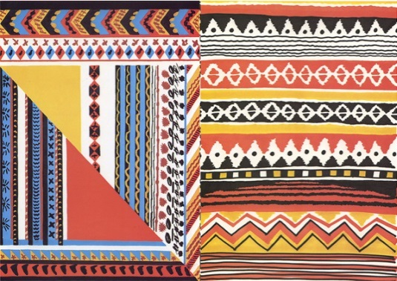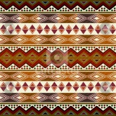
Understand how and why masks are created with some knowledge of the meanings behind some of the symbols.
Create patterns that have been influenced by the African culture and experiment with colour and texture.
Think carefully about the patterns, colour and symbols and the composition of them on my mask.
L.O. Investigate the African craft of mask making, how and why they are created.
Explore West African symbols & meanings

- The masks often express feelings or personal qualities. In the spaces below write a word in a style to express its meaning. For example…
3. Try to draw two African symbols from below
- In each circle below create a pattern that you could use on your mask. You may want to try some of the patterns above.
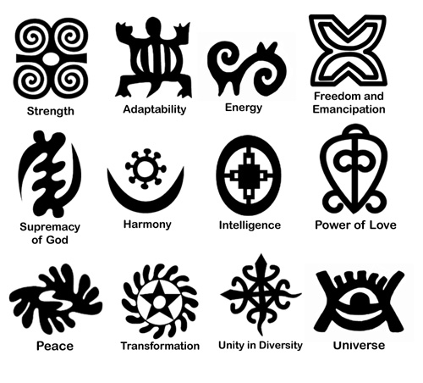

Aim Higher-create your own pattern, think about repetition and how you could use it to create complex patterns

Pencil
- Pick 4 colours that you will use on your mask.
Aim Higher-create one of your own symbols to put on your mask.
Colour
Pen

5. Add patterns and symbols to your own mask to make it reflect you as a person.

Write 2 stars and a wish about your African mask
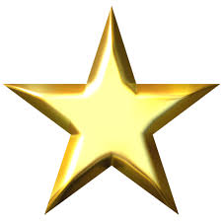
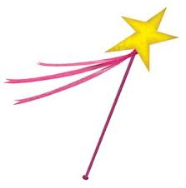

Aim Higher-use similar colours to that of the African patterns.

