8th October 2021
Task: Write a short story about the image below. Who are the characters? What happens in the beginning, middle and end?

Capital letters &  Full Stops  A • |   Connectives | WOW  words | Careful  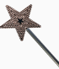  spelling | 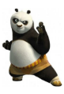  Kung fu punctuation | My writing makes sense.
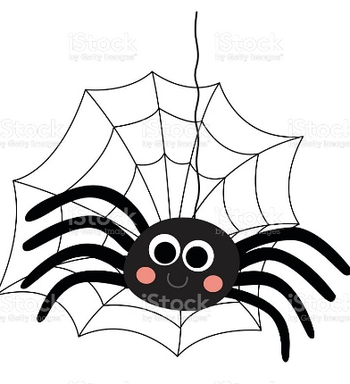
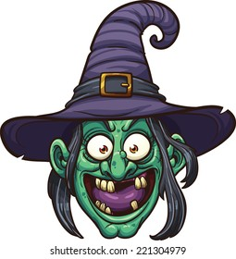
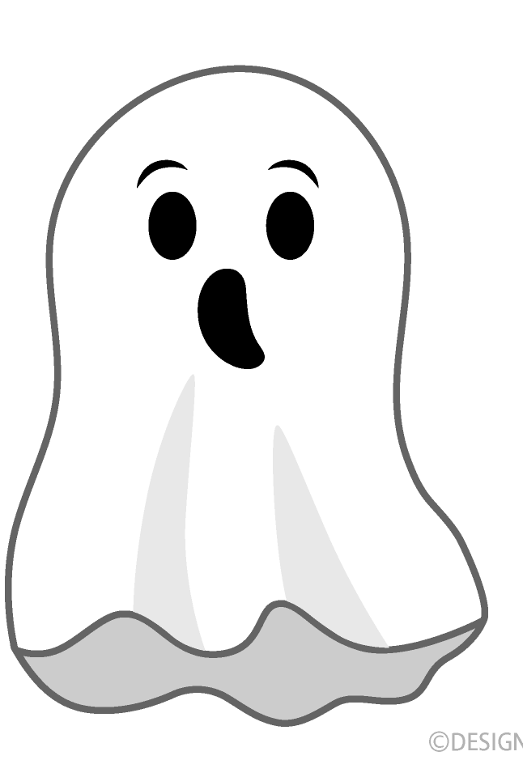
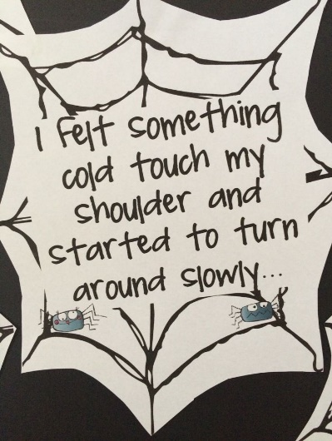
I felt something cold touch my shoulder and started to turn slowly around…. __________________________________ ____________________________________________________________________________________________________________________________________________________________________________________________________________________________________________________________________________________

