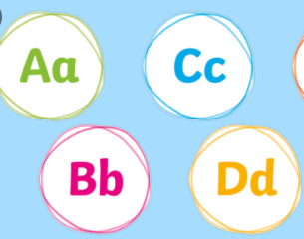
Editing Station 1: Correct your missing capital letters!
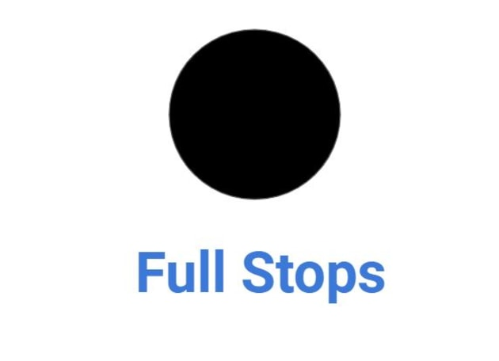
Editing Station 2: Correct your missing full stops!
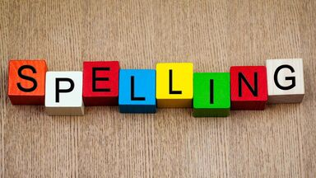
Editing Station 3: Correct your spelling mistakes!

Editing Station 4: Can you improve your word choices?

