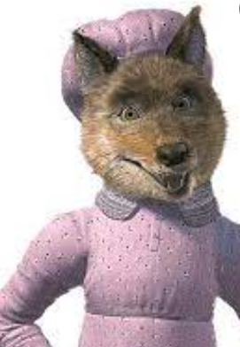
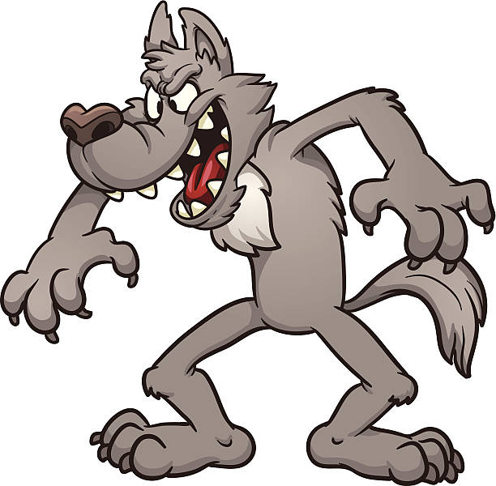
Wanted!

The wolf looks __________________________ _____________________________________
The wolf smells _________________________ _____________________________________
The Wolf is ____________________________
__________________________________________________________________________

