Tuesday 12th October 2021
LO: Compare differences and similarities between the two Grandmas in Little Red Riding Hood.
P |  | CT
 | Must: Can explain what a difference and similarity is.
 | Should: Can sort adjectives and characteristics into similaritiies and differences..
 | Could: Can use multiple adjectives and conjunctions in sentence to compare a character.

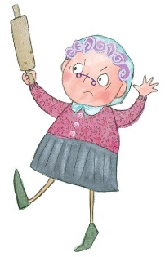
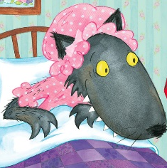
Can you sort the characteristics into similarities and differences?
Similarities

