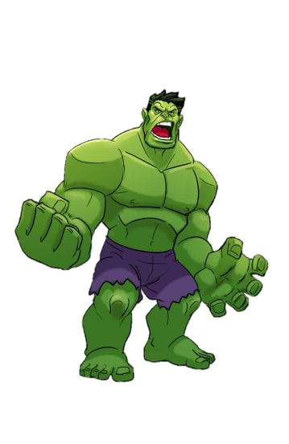
Level up your adjectives!
Level up these adjectives using
small
bad
fast
young
pretty
hot
surprised

