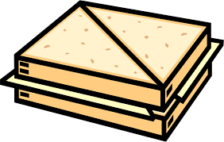
Circle the time connectives in the instructions.
How to make a cheese sandwich
Ingredients:
2 slices of bread
Butter
Grated cheese

Method:
First wash your hands to get rid of germs.
Next take two slices of bread and lay flat.
Then spread butter on top of each slice of bread.
After that sprinkle some grated cheese on one slice of bread.
Finally put the two pieces of bread together and cut into triangles.

Draw a line to match the instruction to the correct step.
Step 4
Step 3
Step 2
Step 1
Secondly squeeze on some toothpaste.
First get your toothbrush.
Finally spit out the toothpaste.
Next brush your teeth for 2 minutes.

