Title Page

By ______________________________________

Contents Page

______________________________________________________________________________________________________________________________________________________________________________________________________________________________________________________________________________________________________________________________________________________________________________________________________________________________________________________________________________________________________________________________________________________________________________________________________________
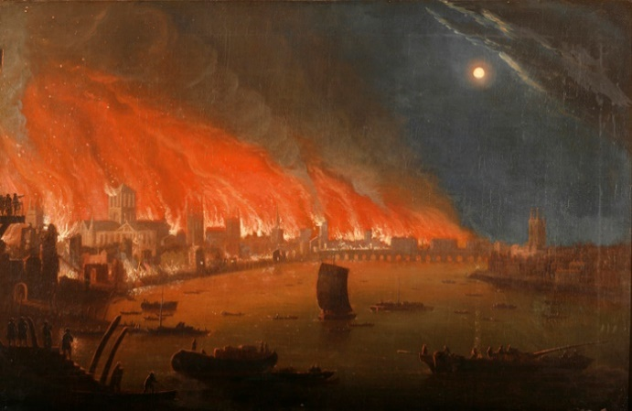
Introduction
_______________________________________________________________________________________________________________________________________________________________________________________________________________________________________________________________________________________________
Section 1

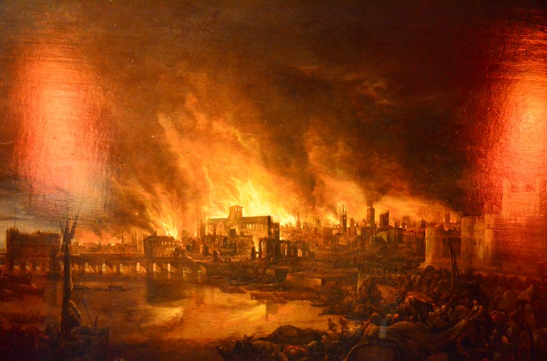
_______________________________________________________________________________________________________________________________________________________________________________________________________________________________________________________________________________________________________________________________________________________________________________________

Section 2



_______________________________________________________________________________________________________________________________________________________________________________________________________________________________________________________________________________________________________________________________________________________________________________________
Glossary

Blurb
____________________________________________________________________________________

