
Oak/Jupiter Class Extension Home Learning Week Commencing 4th January 2021
RE – Hinduism and Sikhism  Now you have collected your information about Hinduism and Sikhism. Can you compare the two religions? Could you tell me similarities and differences between the two?  You can present this in whichever way you prefer. You could create a list or table in your books, you could write paragraphs, you could do another poster, or you could use PowerPoint.     |  | Topic  You have created your painted elephant. Now could you tell me why or when painted elephants are used? Tell me some facts about painted elephants. This can be presented in a poster, a fact file or a leaflet.  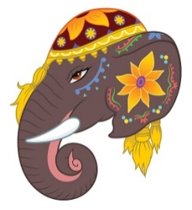
Topic – Geography  Could you create a fact file on India? Telling me the most interesting facts you can find out about India? Remember to use the knowledge organiser on the website and espresso to help you. | Maths  - Continue to complete work on Mathletics/MathsWizz.  - Using the website http://www.timestables.me.uk/ could you create your own quiz of a times table of your choice. Can you see how many you get right and how quickly you can do this.   | PE  Could you come up with your own workout for you or someone else in your house?  

