Date:
LO: to design a chocolate bar
P |  | CT
 | Must: use the survey results to design a chocolate bar.
 | Should: consider the target audience and ingredients
 | Could: explain how your design meets the specification.

What kind of chocolate are you going to use?  Milk Dark White  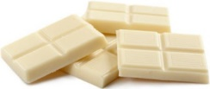  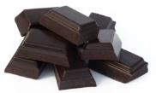  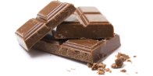 | What toppings will you use?  Biscuit raisins marshmallows sprinkles  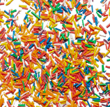  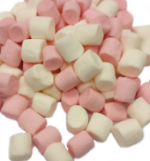  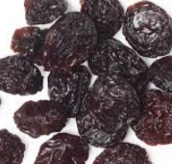  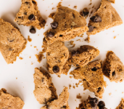
Draw and label your design.

