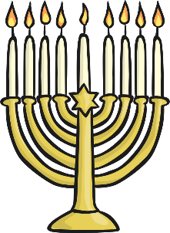 | 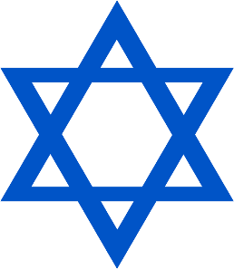  _
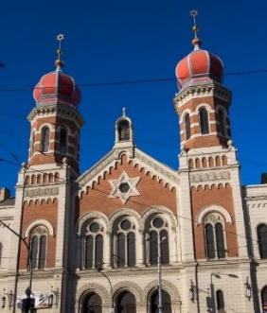 | 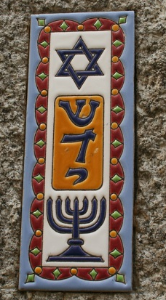
LO: To understand the meaning of some Jewish symbols.
Star of David mezuzah
Worship important
Hanukah menorah Judaism
Festival
Synagogue Rabbi service

Reception Task: Cut out the words to help you label the pictures by sticking the correct word under the correct symbol. Use the powerpoint to help you if you get stuck!

Star of David | mezuzah
menorah | Synagogue

