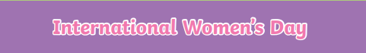
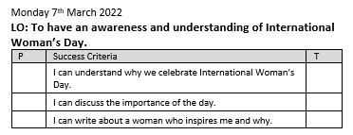
What is International Women’s Day?
__________________________________________________________________________________________________________________________________________________________________
Why is important that we celebrate International Women’s Day?
__________________________________________________________________________________________________________________________________________________________________
Can you tell me something you have learnt about these famous women?
Florence Nightingale:
___________________________________________________________________________________________________________________________________________________________________________________________________________________________________________________
Rosa Parks:
___________________________________________________________________________________________________________________________________________________________________________________________________________________________________________________
Greta Thunberg:
___________________________________________________________________________________________________________________________________________________________________________________________________________________________________________________

