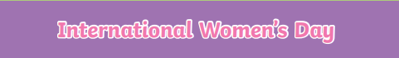
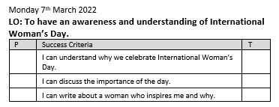
Marie Curie
Michelle Obama
Rosa Parks
Greta Thunberg
I did ground-breaking research on radioactivity that led to the treatment of many illnesses.

I am a lawyer and author. I was the first Black First Lady of the United States.

I am a climate change activist and have
led international campaigns to help the environment.

I campaigned against segregation and for equal rights for Black people in America.

What is International Women’s Day?
International Women’s Day is _________________________________________________________
________________________________________________________________________________

It raises awareness about ____________________________________________________________
_________________________________________________________________________________

Match each of these famous women to the correct fact:

