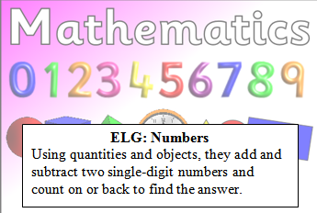
Reception Maths Challenge: Due…………
Use the objects to help solve the following questions. Can you write you write the answer? You might want to use real objects and physically take them away to see how many you have left.
-
=

-
=

Parent comments:
How much support did your child need?
Can your child accurately count the number of objects?
Does your child recognise the subtract sign and knows what it means?

