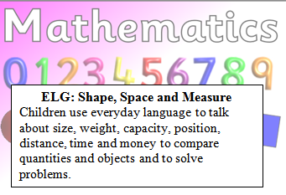
Reception Maths Challenge: Due…………
Have a look at some coins and discuss the following questions.
What do we use money for?
Do you know the names of each coin?
Can you find the coin that is worth the least/most?
Can you name these coins?
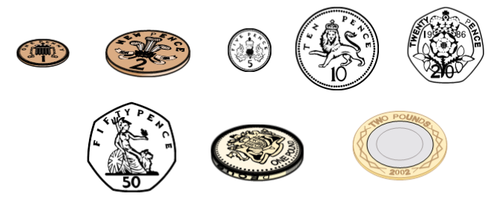

Parent Comments: (Make a note of your discussion and what your child said.)

