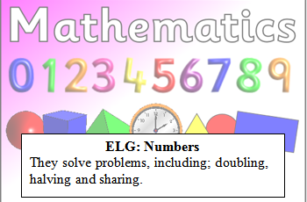
Reception Maths Challenge: Due…………
Can you colour half of each shape?

You have 10 sweets. You share them with a friend so you have half each. How many sweets do you have?
(Do this practically, sharing objects between two people. Do you have the same amount? Do you have half each? Discuss.)

Parent comments:
Does your child know that when we halve something it has to be the same on both sides?
Can your child share objects equally between 2 people?

