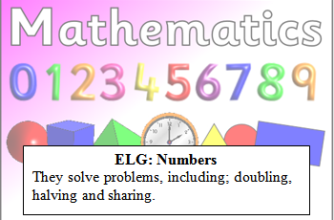
Reception Maths Challenge: Due…………
When you double something you add the same amount again.
Can you double these numbers?

Double 5 is

Double 3 is

Double 4 is

Double 6 is

Parent comments:
Does your child know that when we double we add the same number again?
Can your child count objects reliably?

