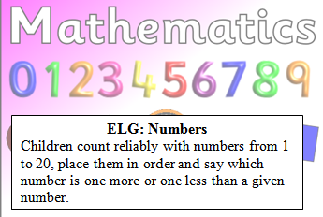
Reception Maths Challenge: Due…………
Fill in the missing numbers on the number line.

1 |  |  |  |  |  |  |  |  | 10 |  |  |  |  |  |  |  |  |  | 20

What is one more than 5?
What is one more than 10?
What is one less than 8?
What is one less than 4?

Parent comments:
How much support did your child need?
Can they count to 20 independently?
Can they count out the correct number of objects? E.G if you say 7 they can give you seven lego cubes.

