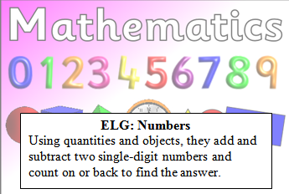
Reception Maths Challenge:
Use the objects to help solve the following questions. Can you write you write the answer? Challenge: Can you write your own addition number sentence?
=
+

=
+

Parent comments:
How much support did your child need?
Can your child accurately count the number of objects?

