
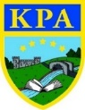
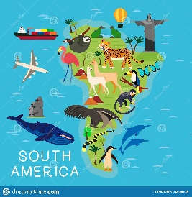
Bean to Bar

Learning Journey—Through our topic ‘Bean to Bar’ the children will continue to learn to build on their knowledge of the seven continents. They will learn about South America and explore similarities and differences compared to where they live. The children will learn about how equator affects the climate of different continents and will compare and locate hot and cold countries. We will be learning to compare the human and physical geographical features of South American countries and where we live.
The children will learn about how chocolate is made and through a design and technology project will create their own chocolate bar and packaging. They will carry out some market research and will present their findings using a range of graphs.
The children will also be exploring the patterns and colours used in Peruvian textiles and will use this to inspire their own printed patterns as well as creating collages influenced by art and textiles from Peru. We will be listening to music from South America and music used during the carnivals such as samba music. The children will learn to clap a rhythm, play un-tuned instruments and listen and identify instruments they can hear.

Key facts:
- South America is one of the seven continents of the world.
- The equator divides the Earth into the north hemisphere and the south hemisphere.
- Chocolate is made from cocoa beans which are grown in tropical zones close to the equator such as parts of Africa and South America.

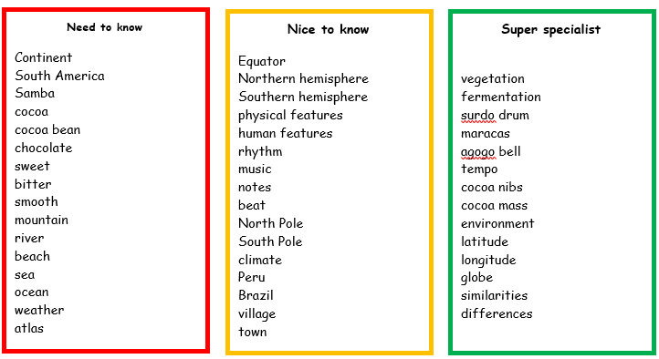
Equator: a line around the Earth, equal distance from the north and south poles which divides the Earth into the northern and southern hemispheres.
Cocoa bean: the seeds of a tropical South America evergreen tree used to make chocolate.
Human geographical features: things you see around you that are man-made.
Physical geographical features: things you see around you that are natural, such as seas, mountains and rivers.

Links to Prior Learning | Key Texts | Links to Future Learning
- The children will build on their previous knowledge of the seven continents and five oceans.  - The children will build on their knowledge of the countries in the United Kingdom.  - The children will build on their knowledge of seasons and weather.  - The children will build on previous learning in maths about graphs and charts as well as making pattern and repeated patterns using 2D and 3D shapes. | - Collins My First World Atlas.  - Charlie and the Chocolate Factory by Roald Dahl  - Recipes and instruction texts  - Poems to Perform by Julia Donaldson  - We’re Going on a Bear Hunt by Michael Rosen.  - ‘Chocolate Cake’ by Michael Rosen. | - Future topics taught in KS2 such as Home and Away,  - Continents and countries  - Weather, climates and seasons.  - Science topics about plants.  - KS2 topics about space.
Family Fun
- Carry out a survey with your family. What is their favourite chocolate bar?
- Make a chocolate cake with your family and then listen to Michael Rosen read his poem ‘Chocolate Cake’- https://www.youtube.com/watch?v=7BxQLITdOOc Can you write your own poem?
- Use Espresso to find out about mountains in South America.
- Watch this BBC documentary about South America: https://www.bbc.co.uk/programmes/m000b9f8
- Watch/read Charlie and the Chocolate Factory!

