Medium Term Planning Overview Jupiter Class Year 2/3 Autumn 2017
Science  - Animals, including humans  - Healthy Animals  - Animals, including humans  - Keeping Healthy | History (main focus) The Victorians  - Queen Victoria  - Famous Inventors  - Children  - Schools  - Homes  - Jobs  - Food | Geography  - Capital city – London – then and now.  - British Empire – Reign of Queen Victoria.  - Using maps, atlases, globes and digital/computer images  - Google Earth
Maths  - White Rose Maths Hub  - NC Maths programme of study 2014  - Number: Place Value  - Number: Addition and Subtraction  - Number: Multiplication and Division. | 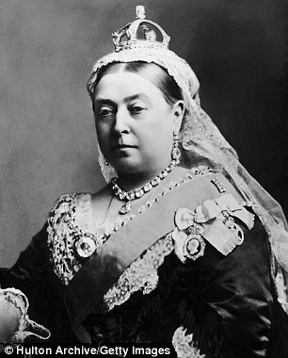  The Victorians | English  - Fiction – Stories in familiar settings  - Fiction – Traditional Tales  - Non-Fiction – Information texts  - Non-Fiction – Writing letters  - Poetry – Study of a poet  - Poetry – Classic Poems
Music  - Listening to famous pieces from Victorian era.  - Composers  - Instruments | PSHE  - Citizenship  - Healthy Lifestyles | Art & Design  - Henry Rousseau and William Morris  - Inventions  - Portraits  - Peg dolls
ICT  - Google Earth  - Using the iPads/Laptops to research in lessons.  - Reading Quizzes, Mathletics and Maths-Whizz | RE  - Christianity | PE  - Table Tennis.  - Dance  - Tag Rugby  - Ball Skills

