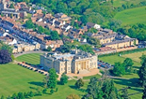
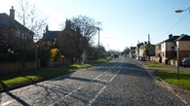
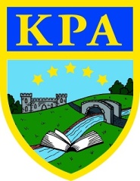
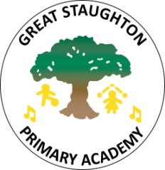
Knowledge organiser:
Home and Away
Spring term 2020
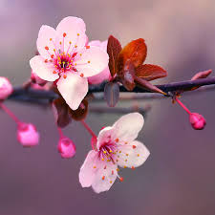
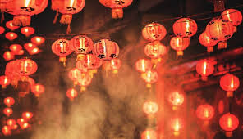
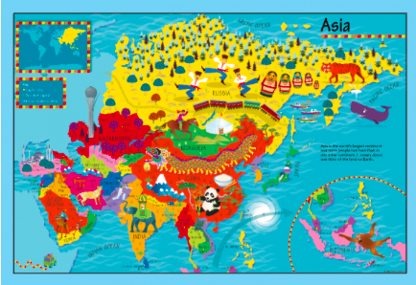
Learning Journey— Children will be learning the geography of their own village and that of the countries of Asia. They will learn key geographical vocabulary and learn to compare human and physical features. They will compare rural and urban living, looking at similarities and differences between life in a village like Kimbolton or Great Staughton, and life in a big city like Shanghai.
In Art, we will be using mixed media to create cherry blossoms, and we will also learn about this Japanese festival through singing the Cherry Blossom song. They will be developing their computing skills to carry out research about different Asian countries, food and culture, and using software to record their learning.
Countries we will learn about:
Japan is a string of islands on the eastern edge of Asia. It is home to some fascinating art, music, food, customs and culture.
China is the largest country in Asia, with a population of 1.4 billion people. Many of them live in towns and cities.
The Kingdom of Cambodia is a country in South East Asia near to Thailand and Vietnam. It is also home to Angkor Wat, the largest religious monument in the world.
Need to know | Nice to know | Super specialist
city | nation | hamlet
town | aeroplane | population
village | urban | suburb
country | rural | region
continent | county | archipelago
land | island | coast
sea | ocean | borders
geography | area | latitude
physical feature | travel | longitude
human feature | transport | globe
map | atlas | festival
north | climate | culture
south | custom | language
east | tradition | sushi
west | kimono | dim sum
China | Thailand | Laos
Japan | Tokyo | kanji
Cambodia | Angkor Wat | Sakura
Shanghai | Olympics | international
Books to read:
I Live in Tokyo by Mari Takabayashi
Suki’s Kimono by Chieri Uegaki
The Magic Paintbrush by Julia Donaldson
Introducing Asia by Anita Ganeri

Links to future learning:
• Other cultures – Egypt (next term) and India (next year)
• Future RE topics: Christianity, Judaism, Islam

Links to past learning:
• European countries – map making
• Chinese New Year
• South America – identifying continents of the world
• Sun, Sea and Sand

Key dates:
Japan’s Cherry Blossom festival is from January through until May (depending on when the trees bloom)
Chinese New Year 2020 – Saturday 25th January
Family fun:
Why not try some Asian foods? Such as…
Yo! Sushi in Cambridge (Japanese food) • Victor Chan in St Neots (Chinese food)
Cinta in Godmanchester (Malaysian food) • Auntie’s Thai in St Neots (Thai food)
For a really big day out… China Town in London would be a fantastic experience. You can also see Chinese New Year decorations on Oxford Street in January! The Victoria and Albert Museum (also in London) has a large collection of Japanese art and textiles.
Children can also learn lots about local history and geography at the St Neots Museum.
Web links:
National Geographic website for kids:
https://www.natgeokids.com/uk/
An interactive slider to track the cherry blossom festival:
https://www.insidejapantours.com/cherry-blossom/

