Medium Term Planning Overview - Jupiter Class Year 2/3 Autumn 2019
Science - In Science this term we will be learning about living things including animals and humans and the importance of their habitats. We will continue to learn about classification of animals and the features they have to survive. We will also be learning about organs in the human body and the importance of their functions and the children will explore, investigate, and explain the systems of the human body. | History -Over the term we will be learning about Tudor history. We will sequence key events in chronically order and place historical artefacts on a timeline to understand the history of events before, during and after the Tudor period. The children will also learn about family trees and they will attempt to create one of the Tudor kings based on their learning. | Geography - In Geography this term we will be developing our knowledge of the continents, oceans, UK countries and capital cities. We will learn to compare the similarities and differences in physical geography from the past to the present day. The children will develop their map reading skills as they use atlases to identify key locations impacted by the Tudor period. They will demonstrate their learning by working in pairs to use a map, globe or an atlas to complete a map themselves.
Maths - In Maths we will be building on the foundation we have developed so far in years 1 and 2. We will be following the National Curriculum for Year 2 and 3 and we will be ensuring the children have a secure understanding of place value and number before moving on to addition, subtraction, multiplication and division. We learn through lots of practical activities and games and will be working on ensuring we can apply our skills in different contexts. | 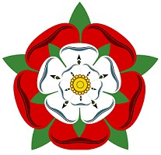  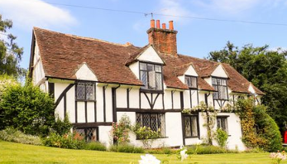  The Tudors | English- In English we follow the National Curriculum for Years 2 and 3. This term we will be focussing on exploring a variety of text types including fiction, non-fiction texts and poetry. We will explore texts which link to our topic in some way such as ‘The boy in the globe’ by Tony Bradman and ‘A midsummer’s night dream’ from the play of William Shakespeare. We will develop our descriptive writing skills by focussing on character description and setting whilst also working hard to develop our spelling, punctuation and grammar skills.
Music- In Music this term we will be using our voices to sing songs, chants and rhymes. We will be learning some new songs as well as experimenting with creating sounds with instruments. We will also focus on the traditional folk tune loved by the Tudors ‘Greensleeves’ this term. We will practise and perform our pieces of music in small groups, ensuring we discuss ways to improve our work. | PSHE- During Circle time on Friday this term will focus on transitions, change, rules and routines. We will explore what makes a good friend and provide children with the chance to share their experiences. We will be using this time to discuss any concerns or worries anonymously. | Art- In Art this term we will focus on developing key skills using colour, brush and pencil strokes. We develop our skills further by painting a portrait of a friend in the style of a Tudor artist; draw a self-portrait using work from Giuseppe Arcimboldo as guidance and we will experiment with clay to create our own Tudor rose.
Computing - In computing this term we will be recap e-safety. The Year 2’s will practise manipulating the computers to save, edit and open their work and both years will use the computers to research key information about the Romans. | RE - In RE we will be exploring a range of religious and special festivals and celebrations including Christmas, Diwali, Hanukkah, Advent and Harvest Festival. We will also compare traditional Tudor celebrations with our own | DT - In DT this term we will design and embroider a Tudor motif. We will sketch a design for a Tudor Rose or Fleur-de-Lys first before using embroidery techniques to create our final design.
PE: Dance, Gymnastics.

