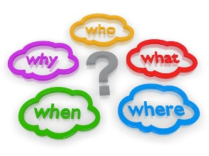

Who? | What? | Where? | When? | Why?

________________________________________________________________________________________________________________________________________________________________________________________________________________________________________________________________________________________________________________________________________________________________________________________________________________________________________________________

