Wednesday 9th June 2021
LO: to compose a simple letter.
P | I can | CT
 | Must: compose a sentence orally before writing it.
 | Should: use some features of a letter (dear/from).
 | Could: write a question in your letter.

Kimbolton Primary Academy
Newtown
Kimbolton
Cambs
PE280HY

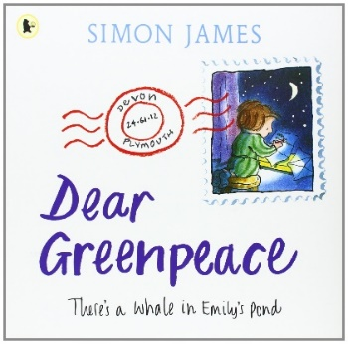
Dear______________________________________________________________________________________________________________________________________________________________________________________________________________________________
whale
greenpeace
from
pond

