
You are invited to

Sari’s

Birthday Party!

Date: 6th of May

Time: 1pm – 3pm

Place: The Sports Hall

from Sari

Dear Sam,

Wishing you a
HAPPY BITHDAY

Love from
Frank and Pam
Unit 1: Day 1: Example letters

Unit 1: Day 1: Example letters

Uncle Hassan,
Busy Street,
Sunny Side Road,
London,
UK.
Dear Uncle Hassan,
I am having a lovely holiday in France. The weather is warm and dry. I have been swimming in the sea and making sandcastles.
Love from Remi
100 Treetop Terrace,
The Forest,
Brazil,
AHH AHH
24th of April 2019
Dear Matilda,

Thank you for the new socks you sent me. They are very colourful and keep my feet warm.

Yours sincerely
Tarzan
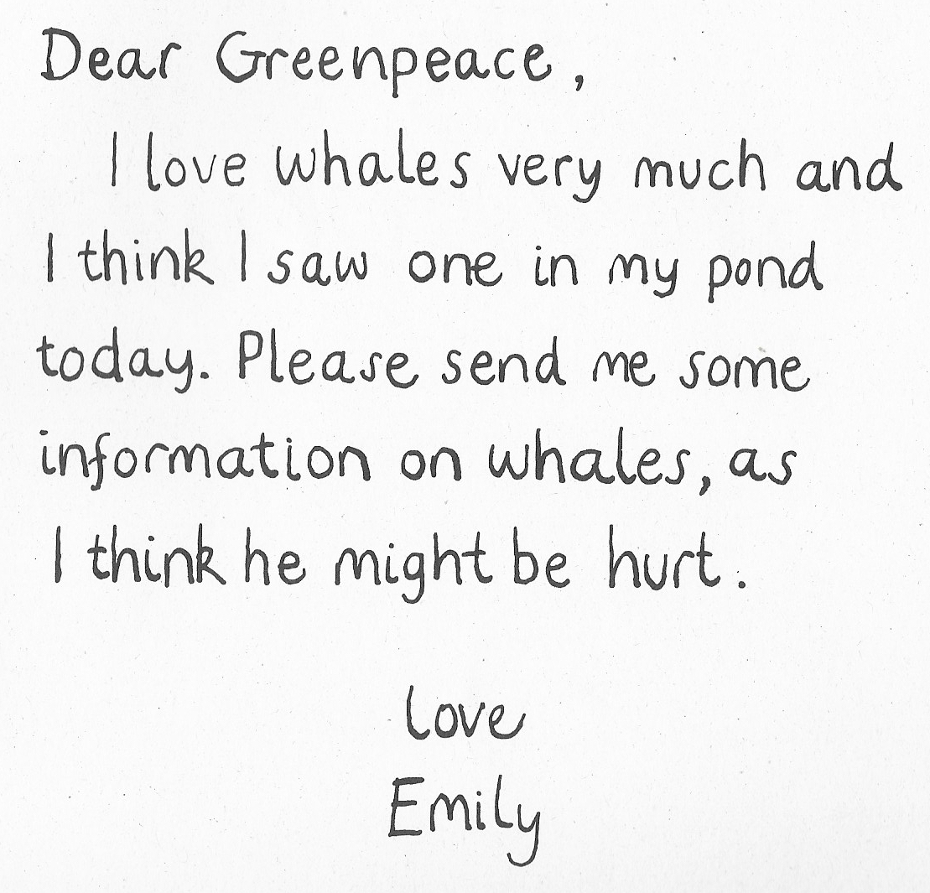
7 Tidy Street,
Orderly-by-the-Sea,
England,
The 17th of May
Dear Mayor,

I want to complain about the litter in the local park. Please arrange for someone to collect it and put it in the dustbin.

Yours faithfully
Ms. Crisp
17 Seaview Road,
Plymouth.
Devon
INSERT RECENT DATE

Unit 1: Day 1: Example letters
Why was the letter written?

- Read each letter from Dear Greenpeace.
- Think about why the letter was sent.
- Cut out the ideas.
- Match them to the correct letter.
asking for information about whales | giving information about whales | asking where whales live
telling where whales live | asking if it is a blue whale | giving information about blue whales

Unit 1: Day 2: Easier
Kimbolton Primary Academy
Newtown
Kimbolton
Cambs
PE280HY
9th June 2021
Dear Henry
I think there is a whale in Emily’s pond because she is able to describe it very clearly and she has stroked his head.

What would you like to find in your garden pond?

from Lawson

Unit 1: Day 3: Example Input
INSERT THE ADDRESS OF THE SCHOOL HERE
INSERT THE DATE HERE

Unit 1: Day 3: Activity/Harder
INSERT THE DATE HERE
INSERT THE ADDRESS OF THE SCHOOL HERE
I think there
What do you think

Unit 1: Day 3: Easier
Unit 1: Day 4: Input and Activity
Thank You

